**Claw Machine**

1. State Transition Diagram

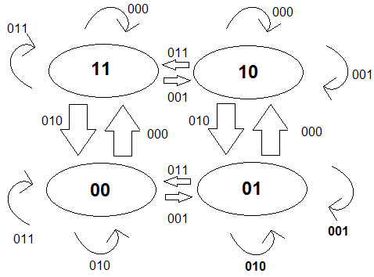

2. Excitation Table

|  |  |  |  |  |  |  |  |  |
| --- | --- | --- | --- | --- | --- | --- | --- | --- |
|  | | | **Q(t)** | | **Q(t+1)** | |  | |
| **x** | **y** | **z** | **A1** | **A2** | **A1** | **A2** | **DA1** | **DA2** |
| 0 | 0 | 0 | 0 | 0 | 1 | 1 | 1 | 1 |
| 0 | 0 | 0 | 0 | 1 | 1 | 0 | 1 | 0 |
| 0 | 0 | 0 | 1 | 0 | 1 | 0 | 1 | 0 |
| 0 | 0 | 0 | 1 | 1 | 1 | 1 | 1 | 1 |
| 0 | 0 | 1 | 0 | 0 | 0 | 1 | 0 | 1 |
| 0 | 0 | 1 | 0 | 1 | 0 | 1 | 0 | 1 |
| 0 | 0 | 1 | 1 | 0 | 1 | 0 | 1 | 0 |
| 0 | 0 | 1 | 1 | 1 | 1 | 0 | 1 | 0 |
| 0 | 1 | 0 | 0 | 0 | 0 | 0 | 0 | 0 |
| 0 | 1 | 0 | 0 | 1 | 0 | 1 | 0 | 1 |
| 0 | 1 | 0 | 1 | 0 | 0 | 1 | 0 | 1 |
| 0 | 1 | 0 | 1 | 1 | 0 | 0 | 0 | 0 |
| 0 | 1 | 1 | 0 | 0 | 0 | 0 | 0 | 0 |
| 0 | 1 | 1 | 0 | 1 | 0 | 0 | 0 | 0 |
| 0 | 1 | 1 | 1 | 0 | 1 | 1 | 1 | 1 |
| 0 | 1 | 1 | 1 | 1 | 1 | 1 | 1 | 1 |

3. State Equations with K-Maps

DA1 = x’y’z’ A1 A2 + x’z A1

|  |  |  |  |  |  |  |  |  |  |
| --- | --- | --- | --- | --- | --- | --- | --- | --- | --- |
|  | X’ | | | |  | X | | | |
| A1 ’A2’ | A1’ A2 | A1 A2 | A1 A2’ | A1 ’A2’ | A1’ A2 | A1 A2 | A1 A2’ |
| y’z’ | 1 | 1 | 1 | 1 | 0 | 0 | 0 | 0 |
| y’z | 0 | 0 | 1 | 1 | 0 | 0 | 0 | 0 |
| yz | 0 | 0 | 1 | 1 | 0 | 0 | 0 | 0 |
| yz’ | 0 | 0 | 0 | 0 | 0 | 0 | 0 | 0 |

DA2 = x’y’z’ A1a2 + x’yz’ A1’ A2 + x’y’ A1’ A2’ + x’y’z A1’ + x’y A1 A2’ + x’yz A1

|  |  |  |  |  |  |  |  |  |  |
| --- | --- | --- | --- | --- | --- | --- | --- | --- | --- |
|  | X’ | | | |  | X | | | |
| A1 ’A2’ | A1’ A2 | A1 A2 | A1 A2’ | A1 ’A2’ | A1’ A2 | A1 A2 | A1 A2’ |
| y’z’ | 1 | 0 | 1 | 0 | 0 | 0 | 0 | 0 |
| y’z | 1 | 1 | 0 | 0 | 0 | 0 | 0 | 0 |
| yz | 0 | 0 | 1 | 1 | 0 | 0 | 0 | 0 |
| yz’ | 0 | 1 |  | 1 | 0 | 0 | 0 | 0 |

4. Circuit Implementation in Logisim